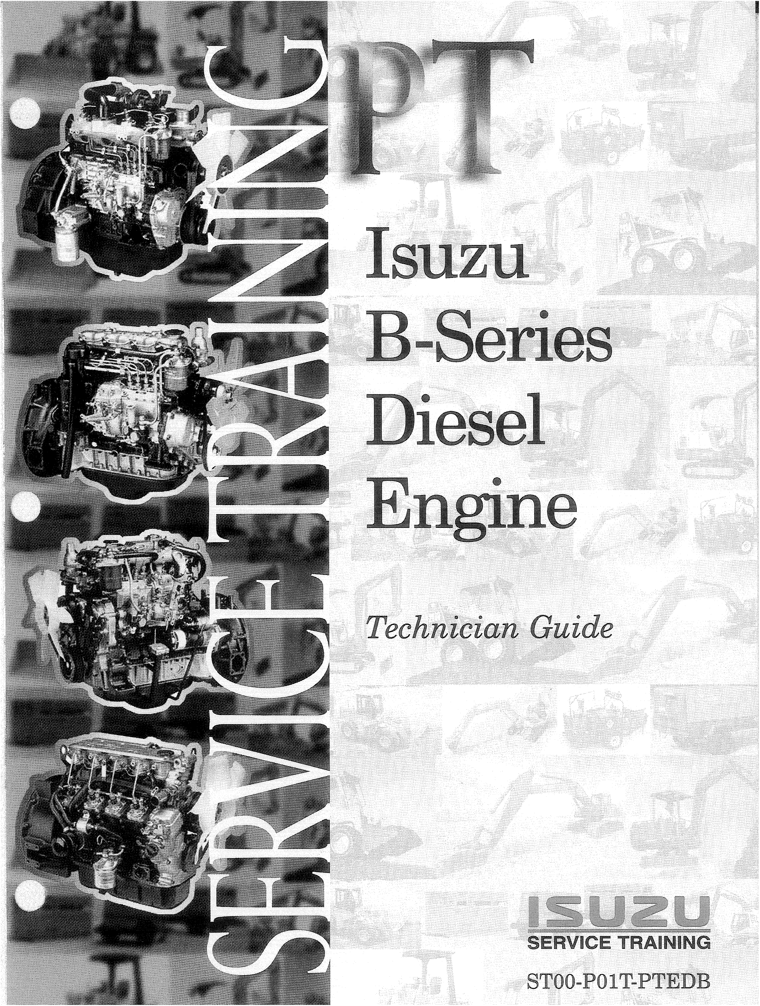

FORWARD
SECTION I. INTRODUCTION

Application Notes
Engine Maintenance Schedule
Engine Identification

SECTION II. ENGINE COMPONENT DESCRIPTION
Injection Pump
Fuel Injectors, Turbo System

Valve Train
Cylinder Head and Head Gasket Crankshaft Pulley
Timing Gears
Camshaft and Removal Crankshaft, Cylinder Block Pistons and Connecting Rods Cylinder Liners
Lubrication System
Cooling System
SECTION III. ENGINE SERVICING PROCEDUR-ES Valve Adjustment

Oil Filter Service
Fuel Pump Strainer, Main Fuel Filter

Spill Port Timing and Injection Pump Timing Adjustment
Injector Service
Injector Pop-Off Test
Injector Leak Test
Glow Plug Inspection
Cooling System Service Information

SECTION IV. ENGINE REPAIR SPECIFICATIONS
Engine Maintenance Specifications
Engine Mechanical Specifications (Cylinder Head/ Valve Train/ Short Block) Engine Torque Specifications (Cylinder Head/ Valve Train/ Short Block) Lubrication and Sealer Specification

SECTION V. COMPONENT FAILURES
Nozzle Component Failure
Piston Failures
Turbocharger Failures

SECTION VI. APPENDIX - SERVICE INFORIMATION
Nozzle Trouble Diagnosis
Nozzle Performance Diagnosis
Nozzle Holder Tightening Standards
Turbocharger Boost Pressure Diagnosis
Tests: Exhaust Temperature, Crankcase Pressure, Inlet Manifold Pressure Used Oil Sample Data
1
2
3
4-5

6
7
8 9-10 11-12 13
14
15 16-17 18 19-22 23-25

26
27 28-29 30-33 34-35 36
37
38
39

40 41-42 43
44

45-47 48-49 50
51
52 53-54 55
56
57
THIS PAGE LEFT BLANK INTENTIONALLY
.

Forward
This book is designed to cover several aspects of the B-series engines. The following six

sections focuses primarily on the current production 4 and 6 cylinder BG-series which are the 4BG1,4BGlT, 6BG1, and 6BGlT. (Refer to Figure l-l and 1-2 at next page.)

The introduction covers engine application notes, maintenance schedule and information

regarding engine identification. Section two is the engine component section that provides in-depth descriptions of each component. This will include component operation and important points that are critical to the disassembly, inspection and reassembly of the engine. Section three is the engine service section, which highlight important service procedures relevant to the B-series engines. Section four provides a comprehensive listing of engine repair specifications for both the 4B and 6B engines. Section five contains
various component failure illustrations with descriptions. Section six is the appendix, which contains diagnostic information and miscellaneous service information.

Due to the similarities between the 4B & 6B engines, this technician guide covers both

engines. This training manual outlines the important aspects of the repair manual; however, it is not a stand-alone manual. It must be used in conjunction with theappropriate Workshop Manuals.

