Application Notes
The B-series engine has been the workhorse for Isuzu since the 1970’s. Used in a variety

of industrial applications, the B-series engines are available in turbo charged or non-turbo charged configurations and there are about 100 different specifications for this engine. The total volume production of the B-series engine exceeds 2.5 million units. It is also the only diesel engine produced by Isuzu that is available in both automotive and industrial
specifications.
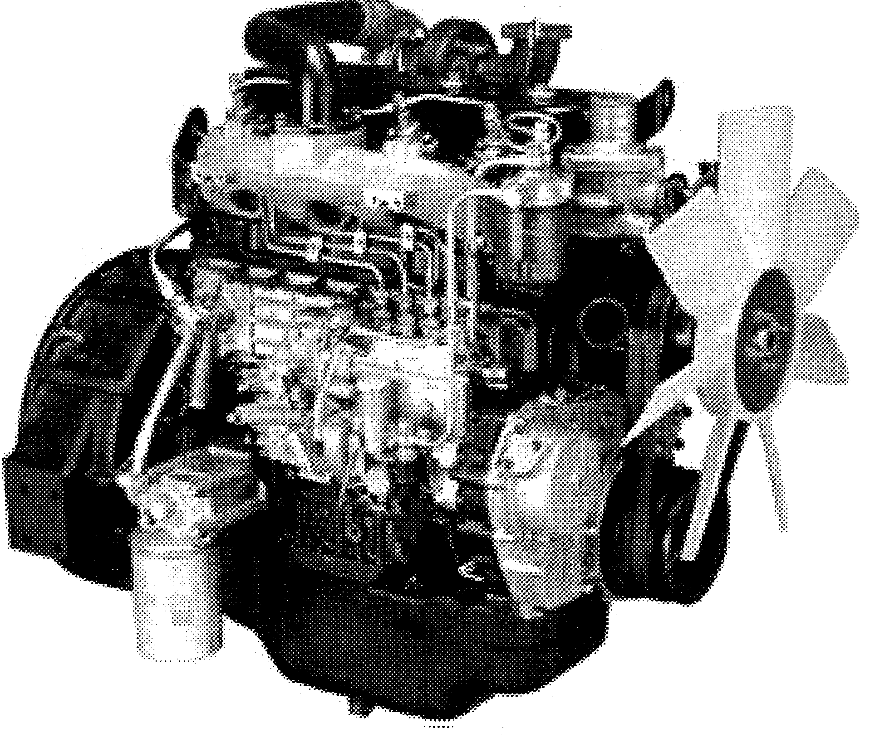
Figure l-l: 4BGlT
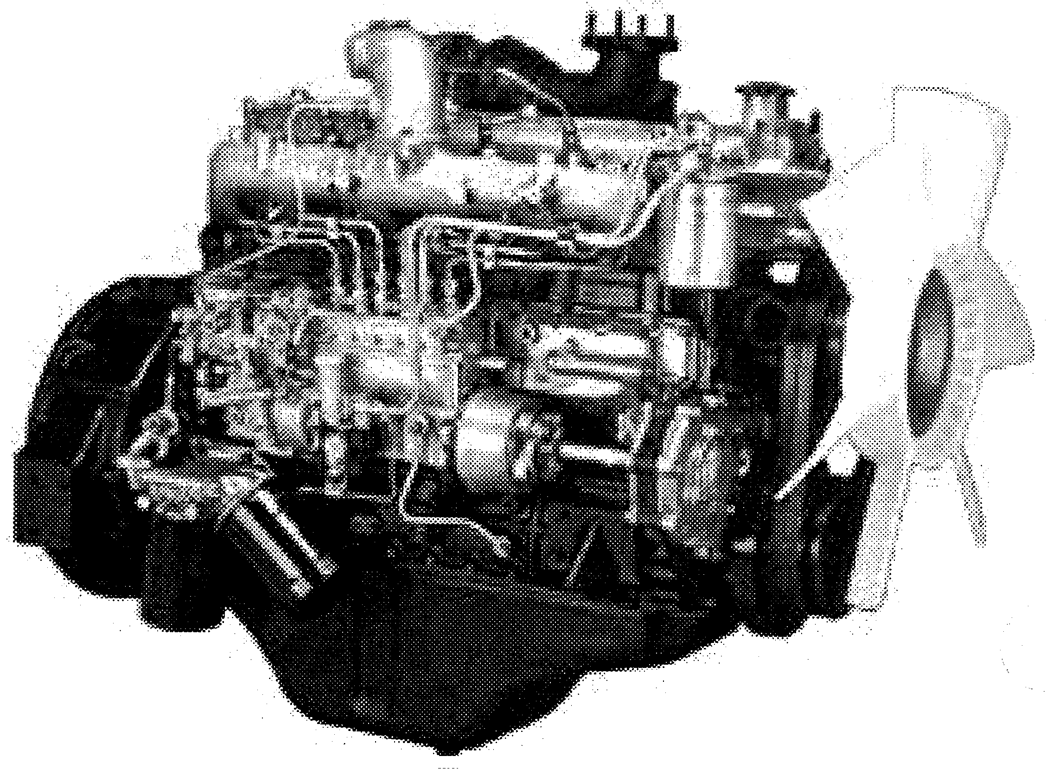
Certain specifications for the B-series engine meet Tier-one emission standards. Changes

to the combustion chamber and pump timing have made it possible for Isuzu to produce an engine that meets such standards but doesn’t require expensive emission control
scrubbing devices.
Figure 1-2: 6BGlT
To further improve the engine, a one-piece bevel cut pump gear, camshaft gear and idler

gear have been incorporated. This ensures correct gear re-alignment without manually having to set gear backlash.

Inside the B-series engine, the connecting rods are forged steel material with full floating

wrist pins. The crankshaft is also forged and the shaft’s journals are tufftrided to improve durability and resist journal wear. The pistons have also been improved. A new lighter weight piston with a barrel shape skirt design has been incorporated.

Etigine Maintenance Schedule
The following maintenance schedule is a comprehensive service program that takes a

preventative approach to engine repair. Isuzu has established these standards with maintenance as the basis for prolonged product life. Isuzu highly recommends that if a
routine maintenance schedule is not part of your customer support service, that one be implemented to better serve your customer’s needs.
There is no service interval specification provided by Isuzu

Refer to the battery MFG or test Battery tool MFG specifications
1 There is no service interval specification provided by Isuzu
There is no service interval specification provided by Isuzu
I I I I
Remove and replace after initial 50 hrs of engine operation.

Then follow the regular maintenance schedule there after.
*
First servicing at 1200 hours
3

