Engine Identification
Important engine identification information can be found at various locations as follows:

Engine Serial Numbers are located on the engine block.

 4BG-series: top front part of the block on the exhaust side. (Figure l-3 and l-4)
 GBG-series: Lower front part of the block on the exhaust side. (Figure l-5 and l-6)
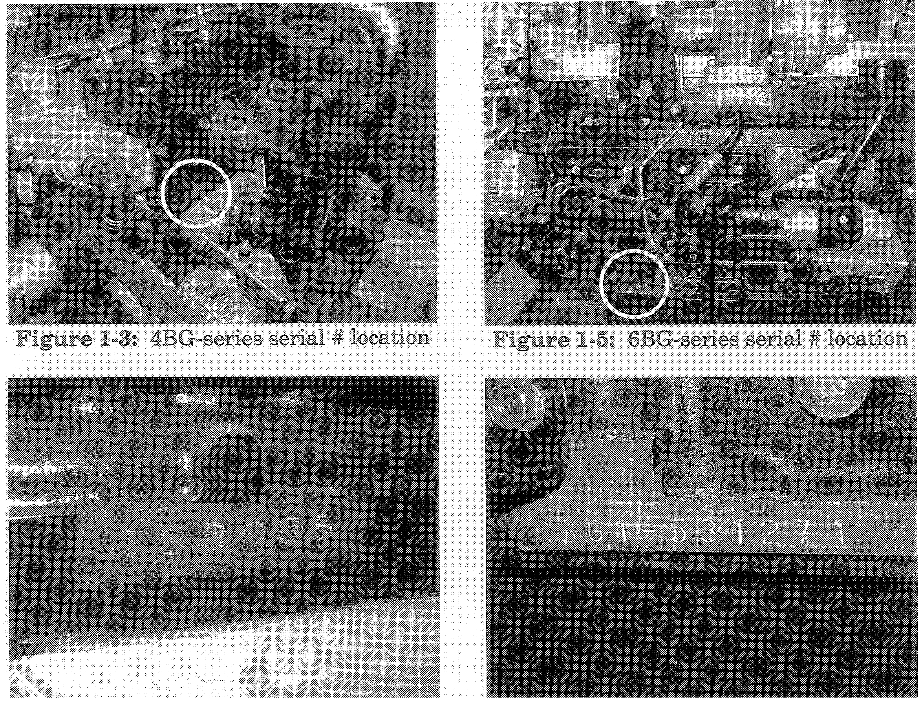
Figure 1-4: 4BG-series serial number Figure 1-6: GBG-series serial number

Engine Identification (continued)
Engine Certification Label is located on the rocker cover. (Figure 1-7 and 1-S)

Specific information for the engine model is included on this label.
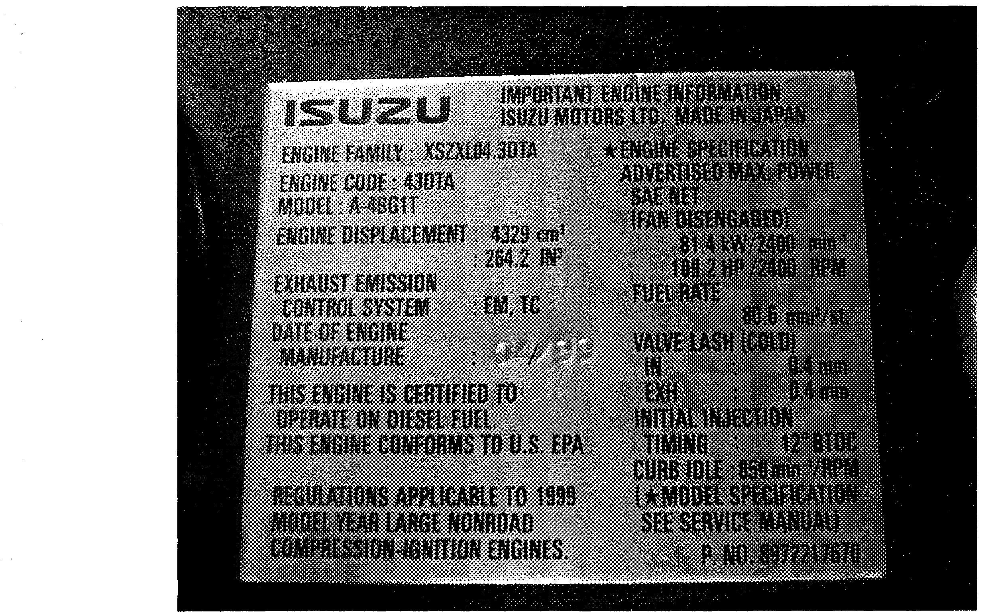
Figure 1-7: 4BG-series label
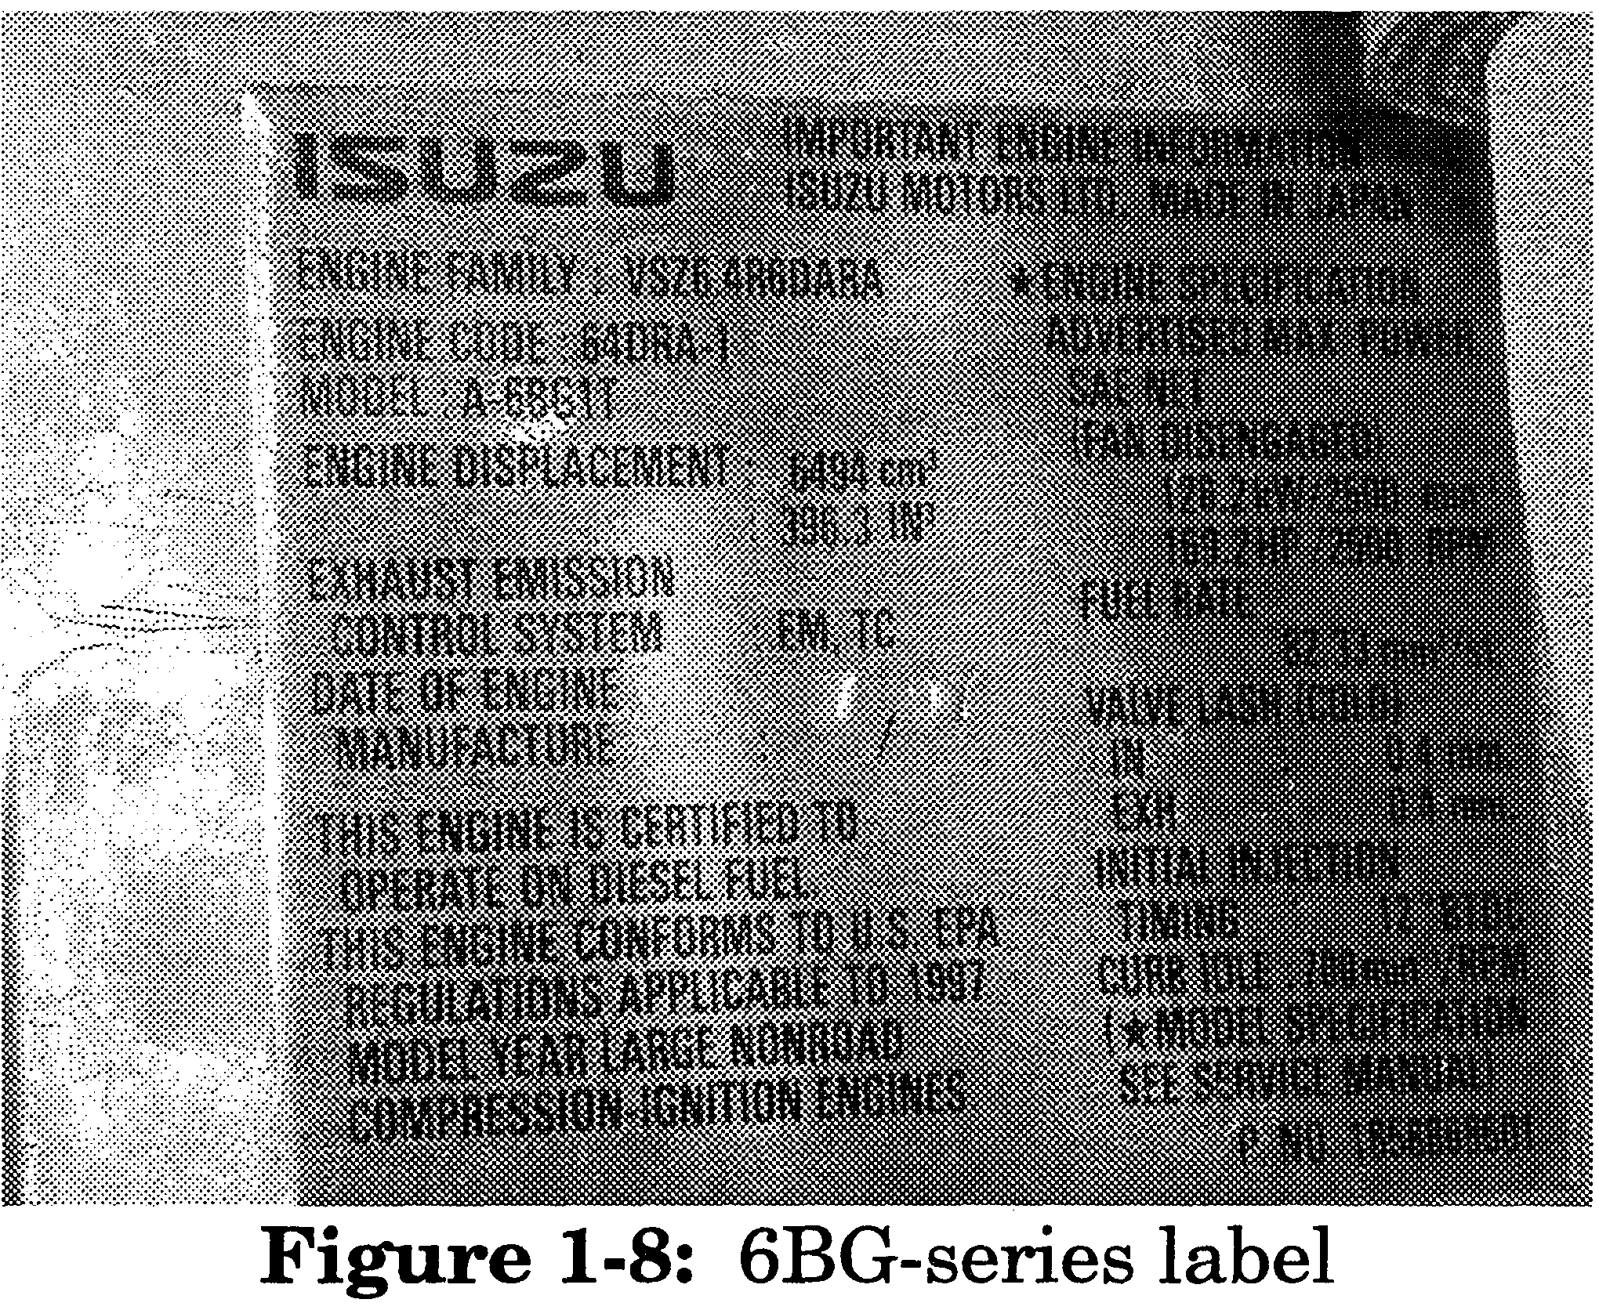
Engine Production Spec Label is located on the rocker cover. (Figure 1-9 and l-10)

Coded information regarding engine build specification and date of manufacture can be found on this label. Spec code is relevant to horsepower, rated RPM and pump timing.
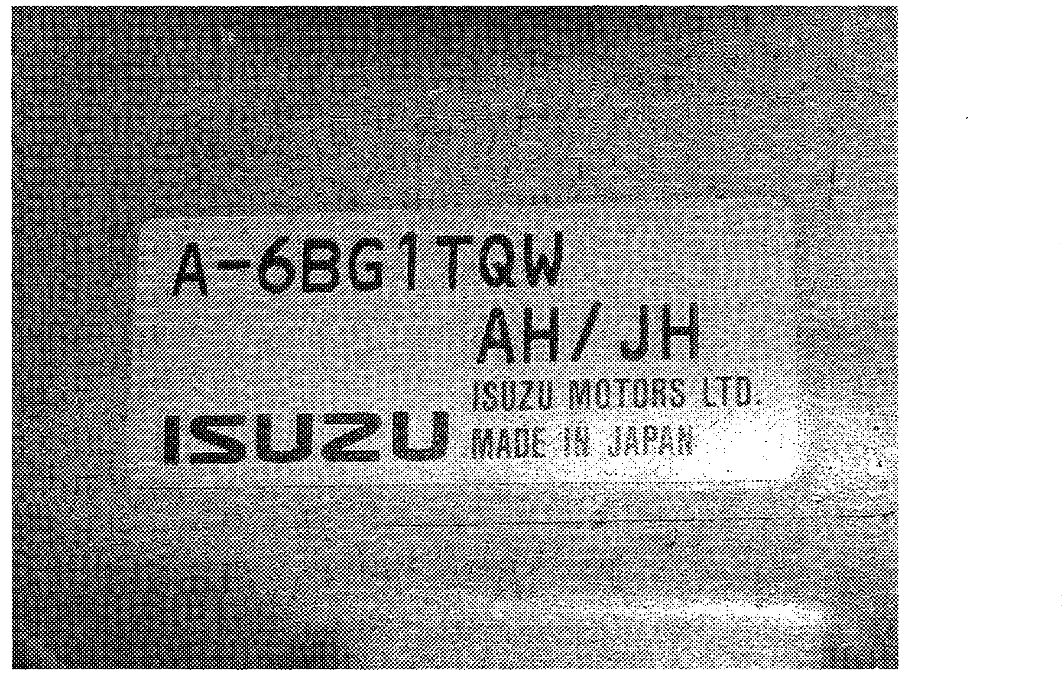
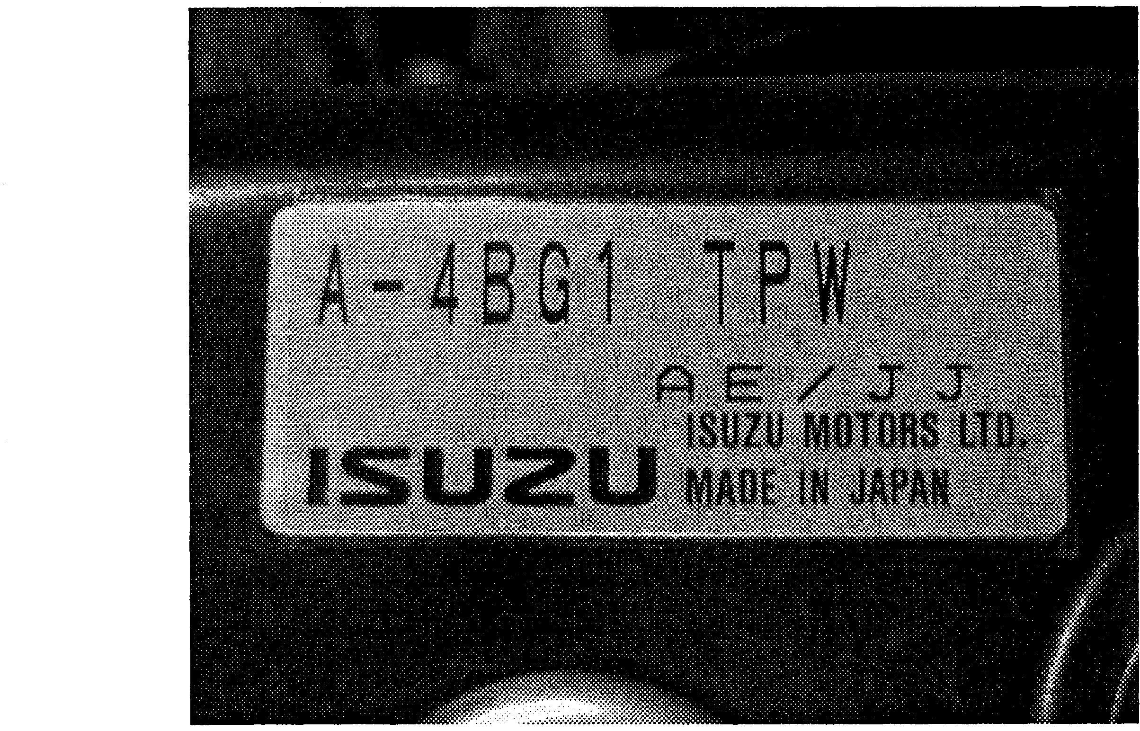
Figure l-9: 4BG sample spec label Figure l-10: 6BG sample spec label
Engine production date is indicated in alpha characters on the label.

Alphacode-to-Numeric: (A=0 B=l C=2 D=3 E=4 F=5 G=6 H= 7 I=8 J=9)
Examples:
O4/99 = AZ3 / JJ (4BG sample labels above on this page)

07/W = AH /’ JH (6BG sample labels above on this page)
5

Injection Pump
Both the turbo and non-turbo versions of the B-series engine come equipped with a Zexel

A-type (4BGseries) or AD-type (GBG-series) mechanical pump (Figure 2-1,2-2, and 2-3). The injection pump used in the GBG-series engine uses an aneroid compensator device to make fuel adjustments relative to changes in atmospheric nressure (Figure 2-2).
L
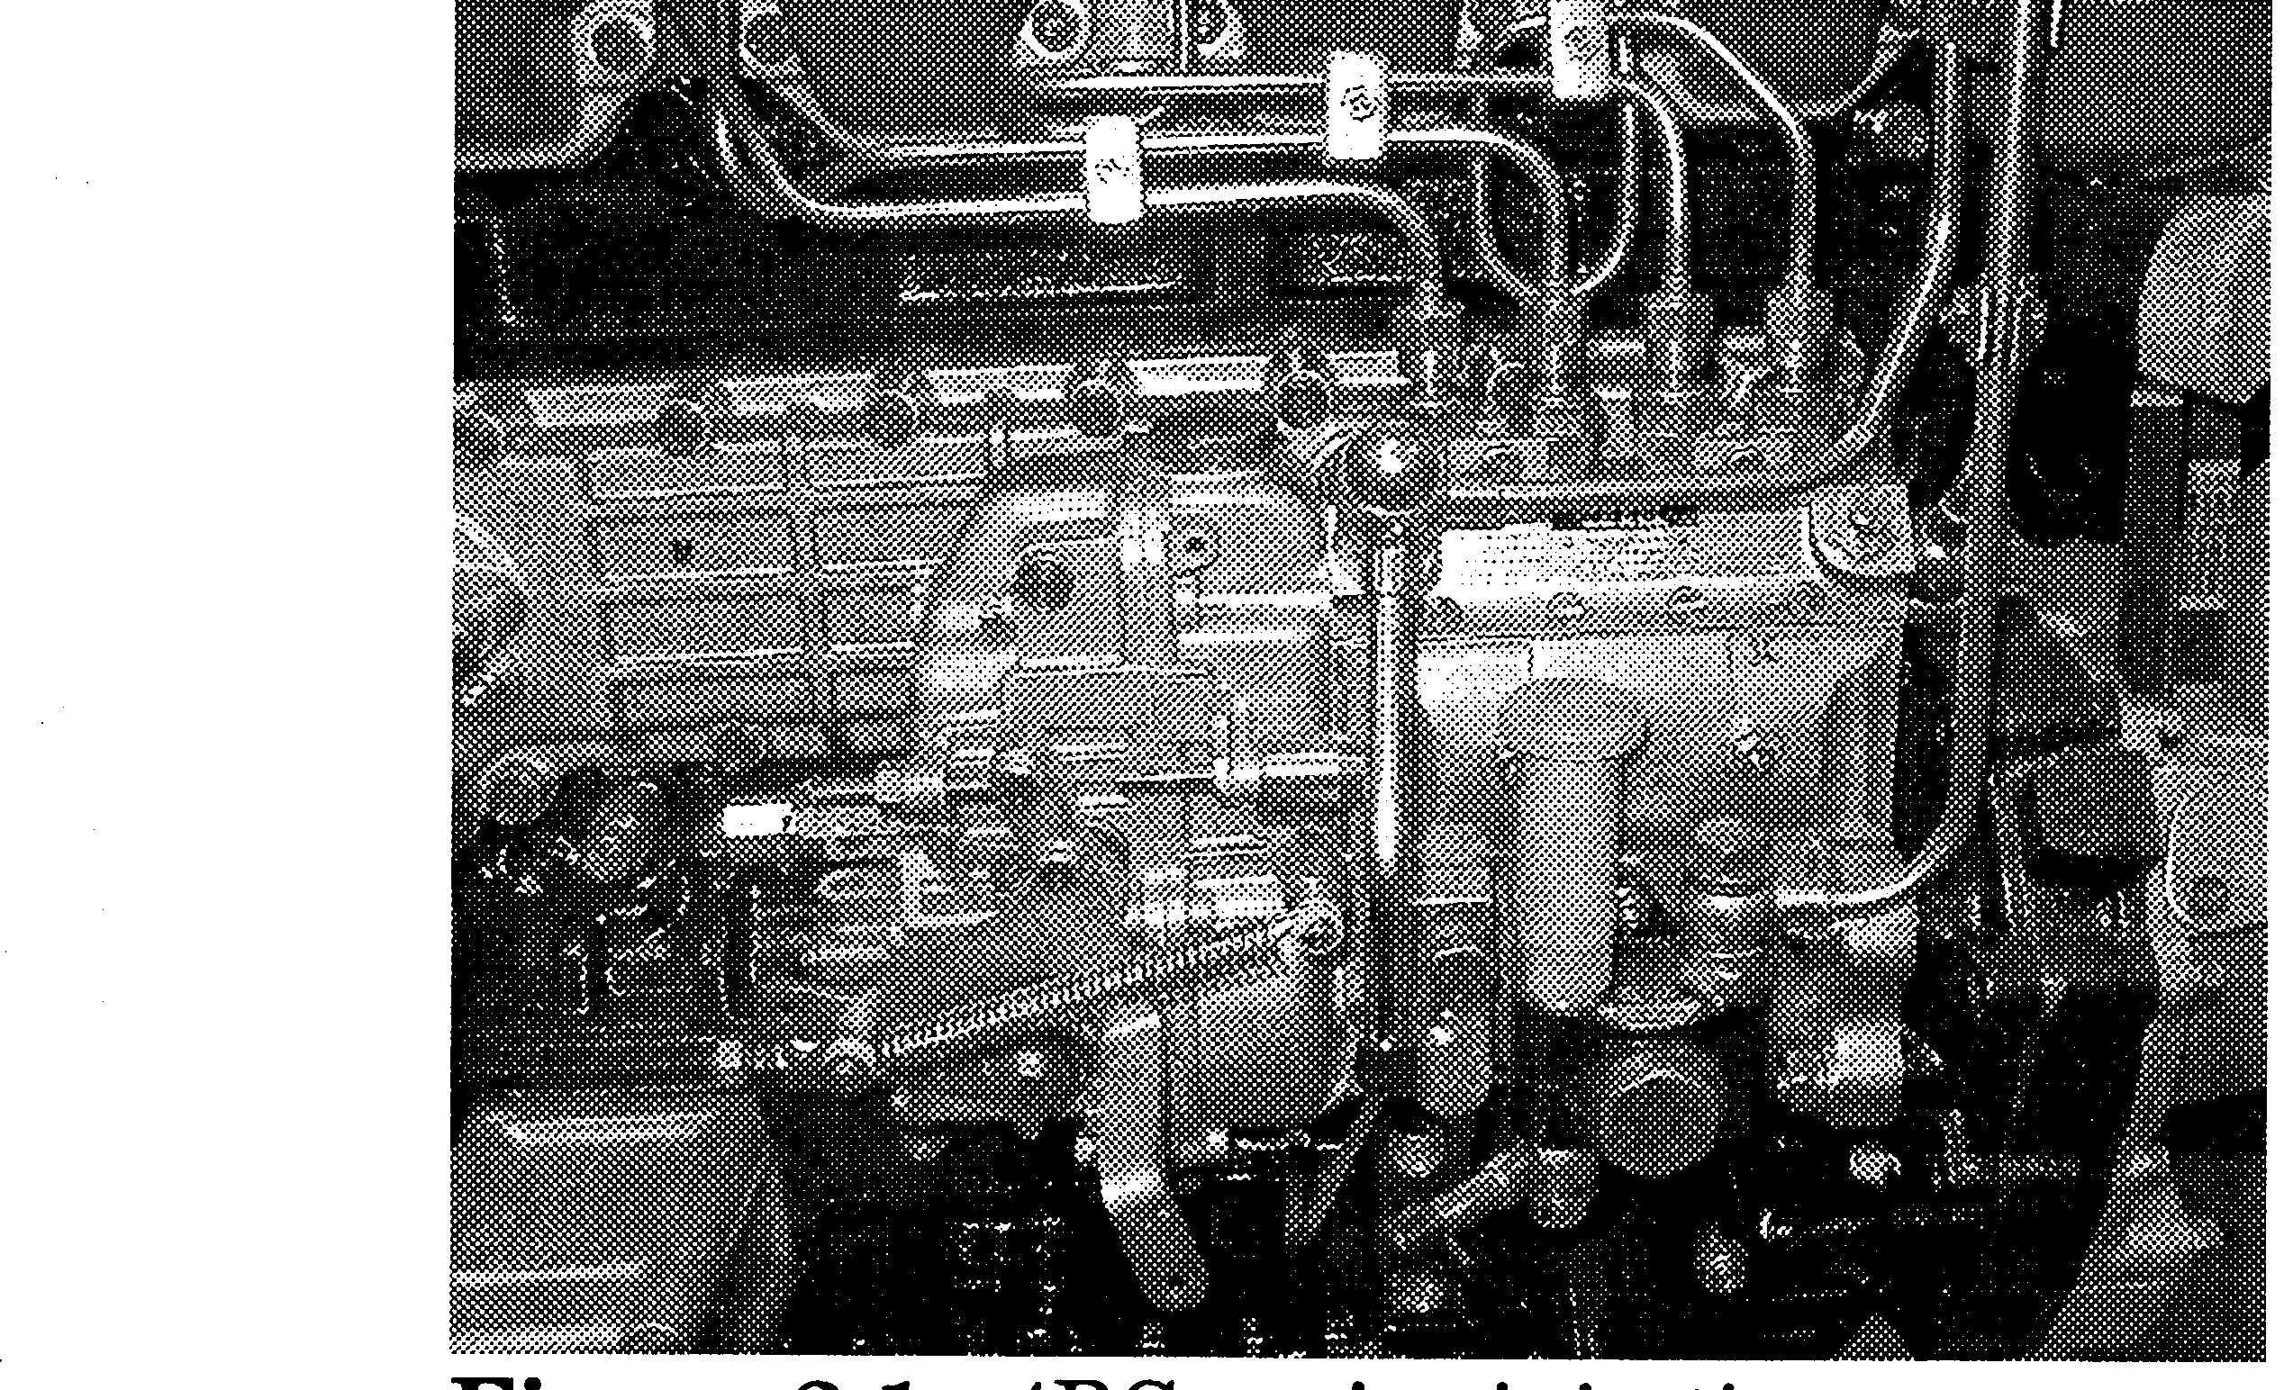
Figure 2-1: 4BG-series injection pump
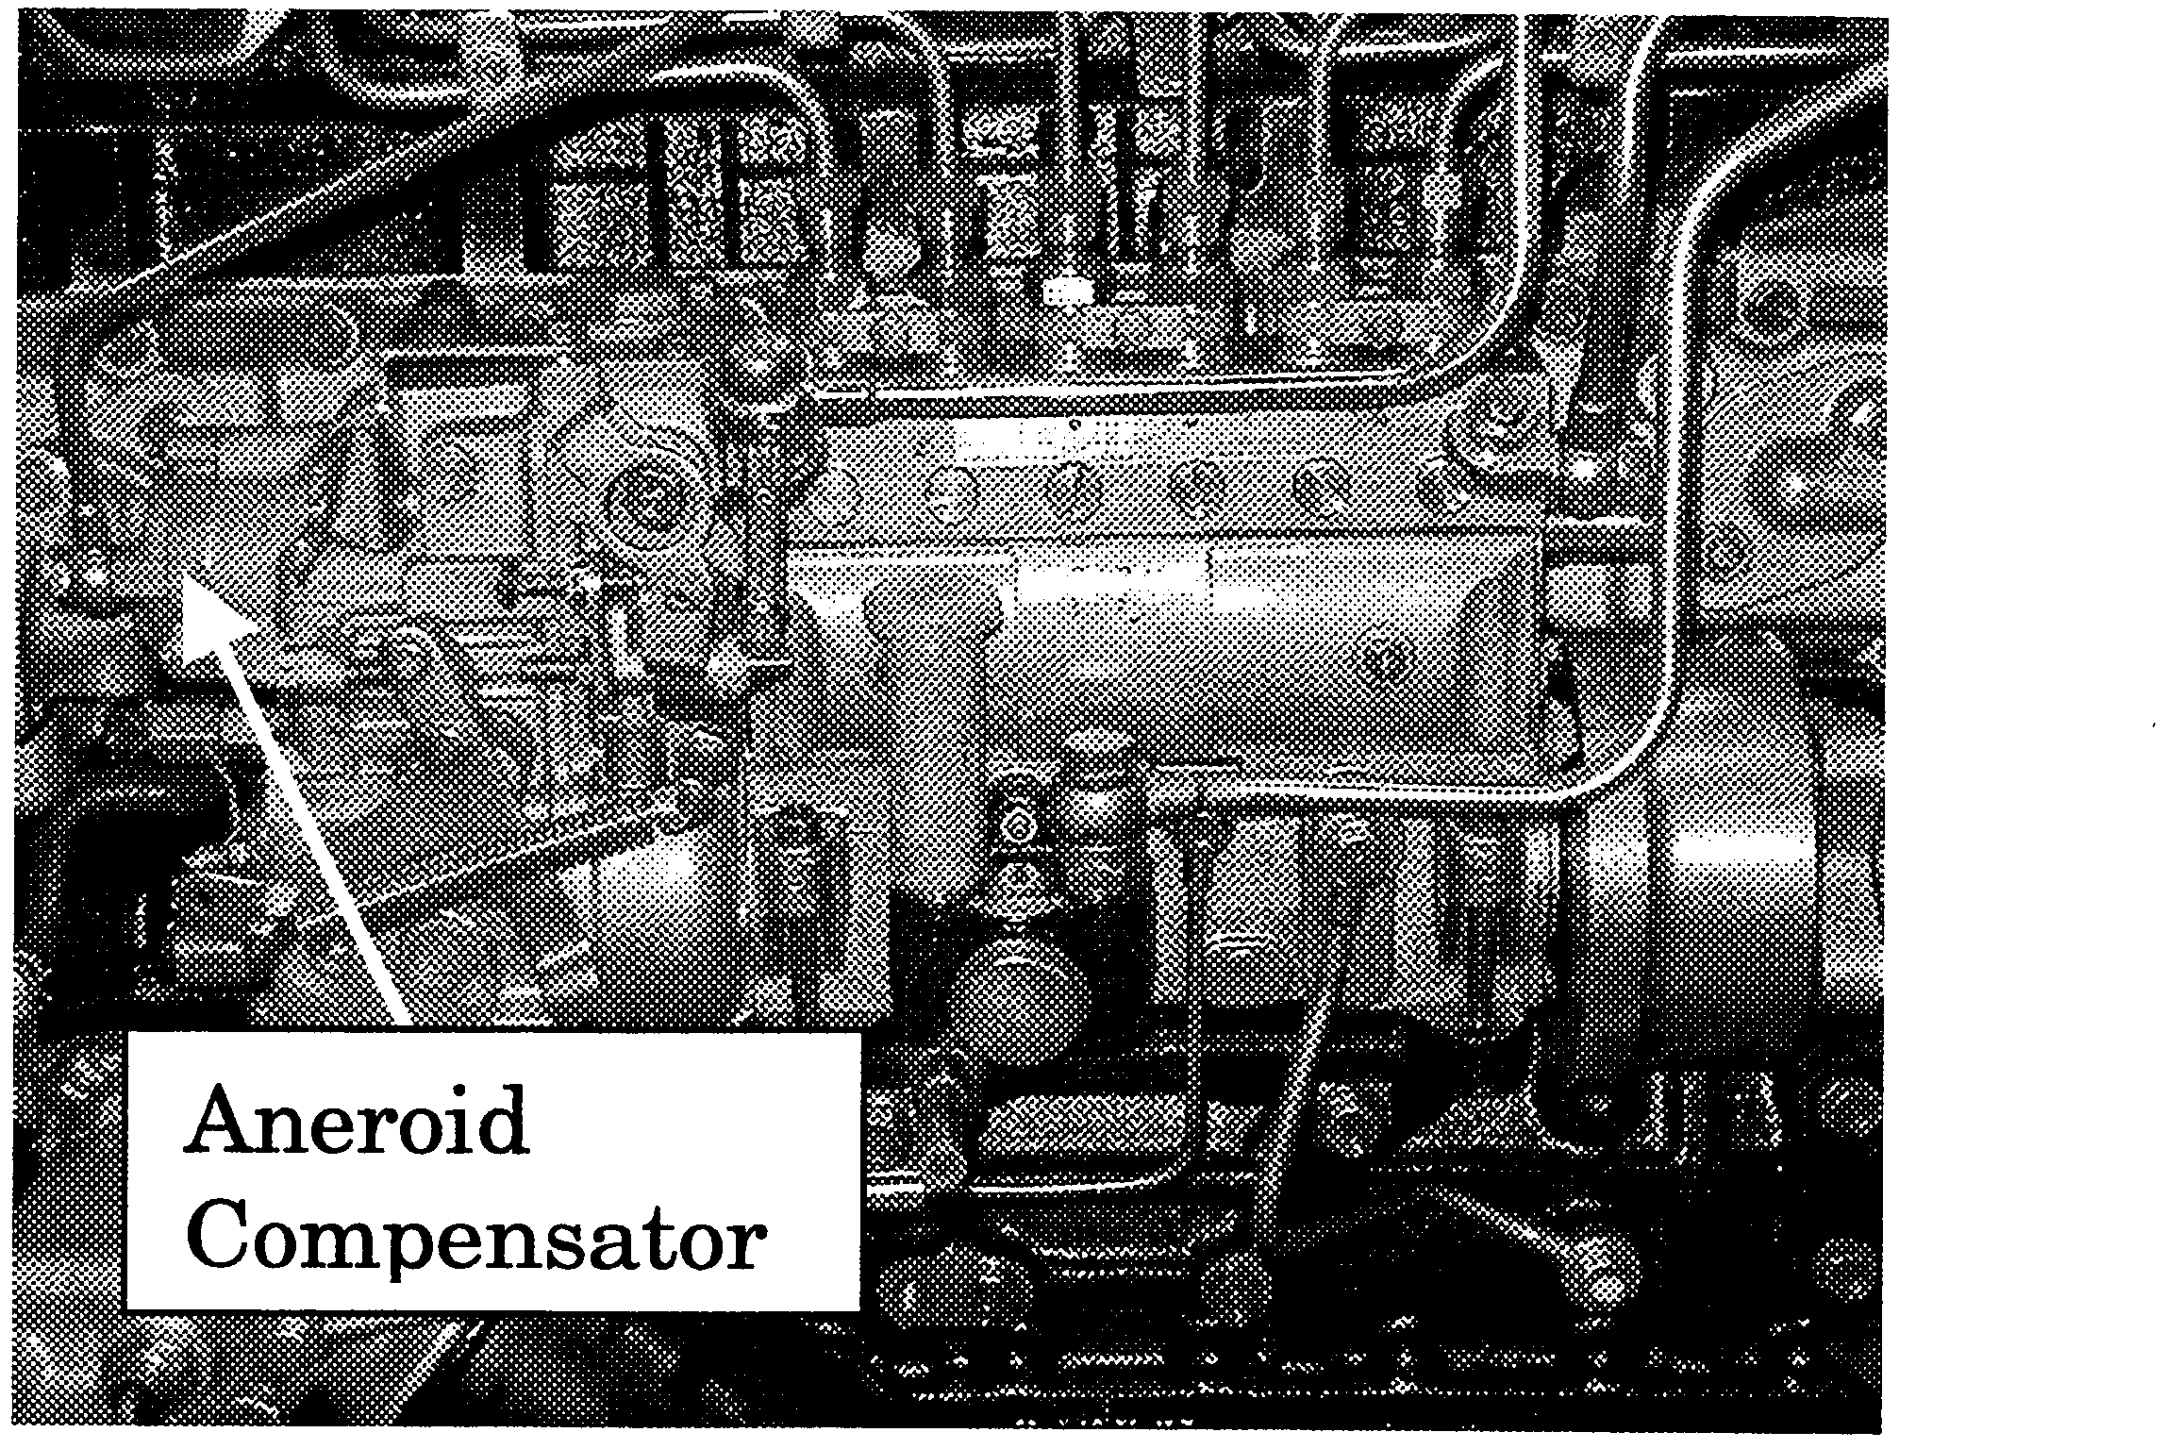
Figure 2-2: 6BG-series injection pump
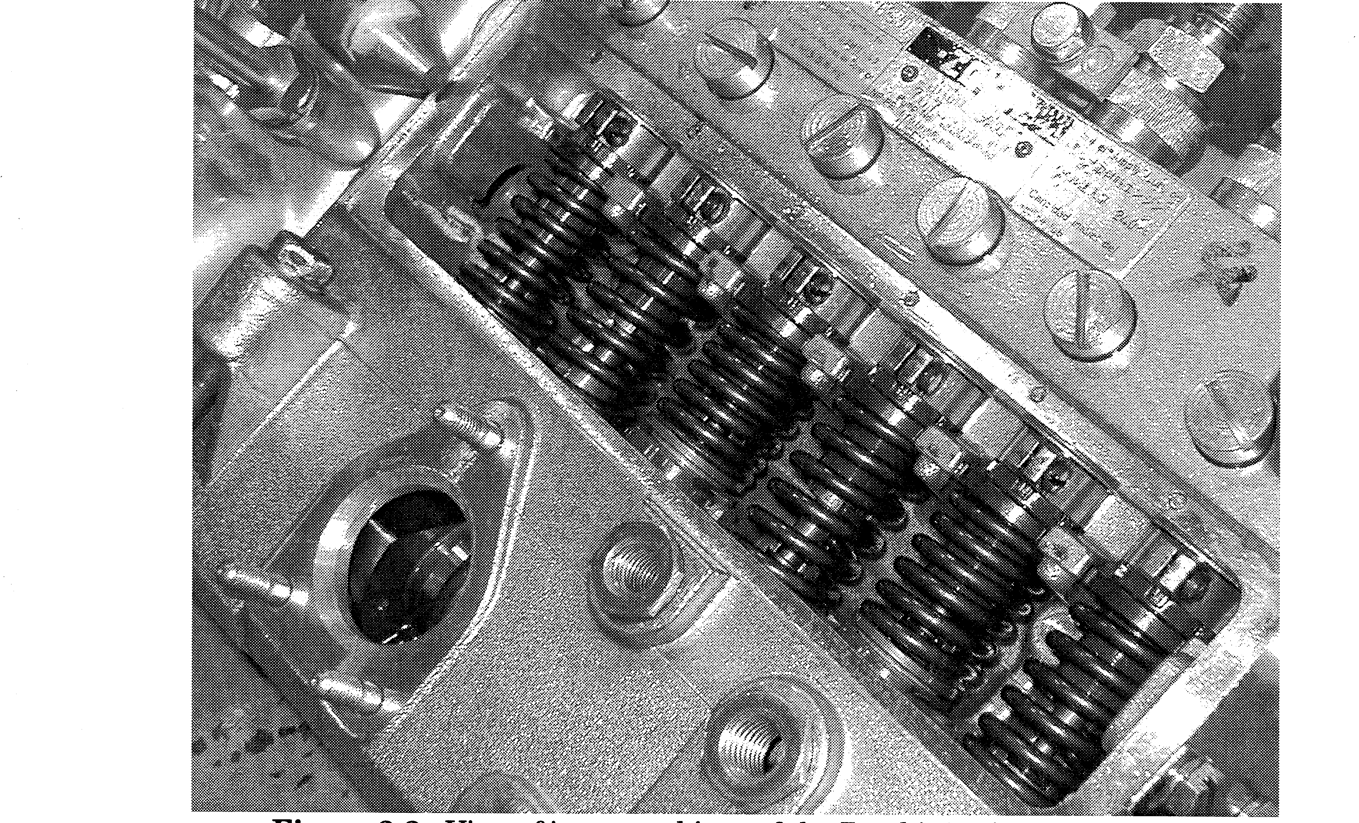
Figure 2-3: View of inner workings of the Zexel injection pump (6BG)6

