Fuel Injectors
All versions of the industrial B-series engines are direct injected, using multi-orifice type

injectors. (Figure 2-4 and Figure 2-5)
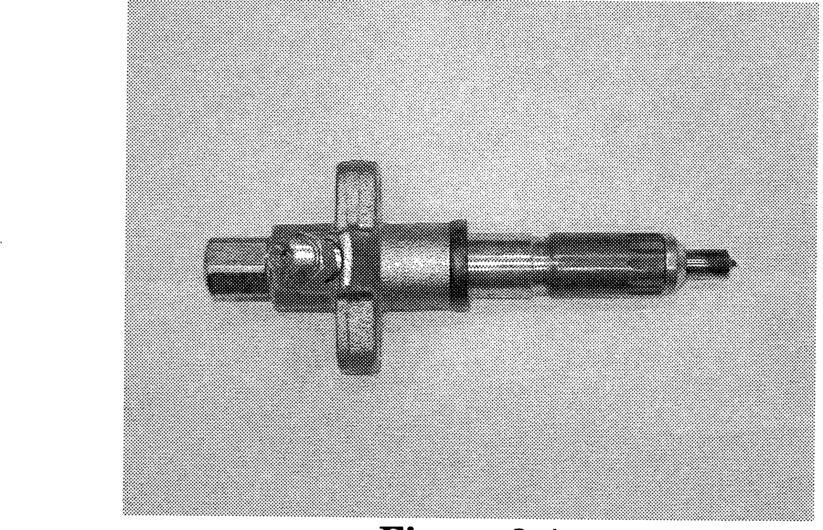
Figure 2-4
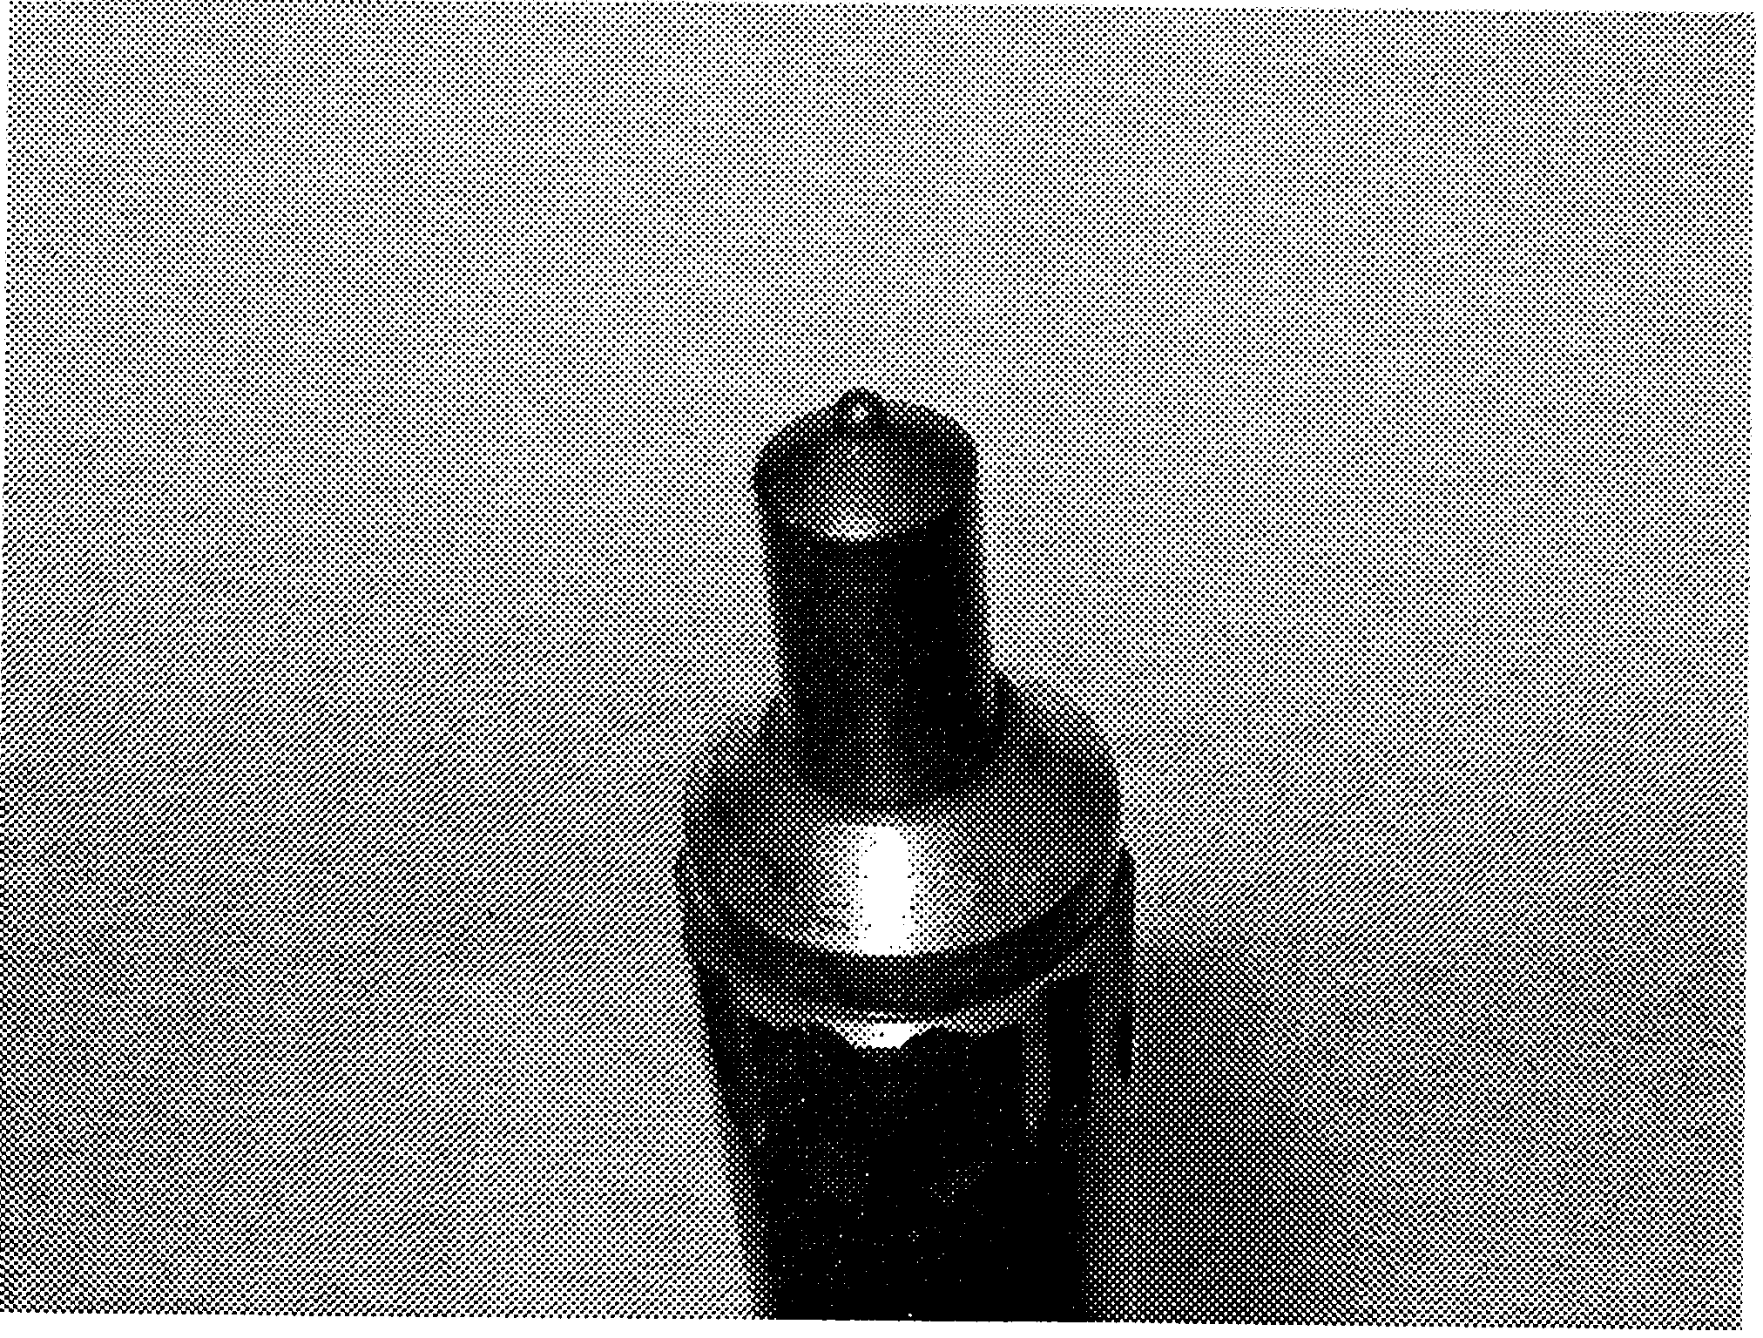
Figure 2-5
Turbo System
The turbo charged version (4BGlT and

6BGlT) does not use a wastegate as a means of regulating turbo boost. Turbo boost is limited by the sizing of the turbocharger’s rotating assembly and housings in relation to the available exhaust energy. This eliminates the need for a wastegate mechanism, allowing a simple, but effective, means of power production. (Figure 2-6)
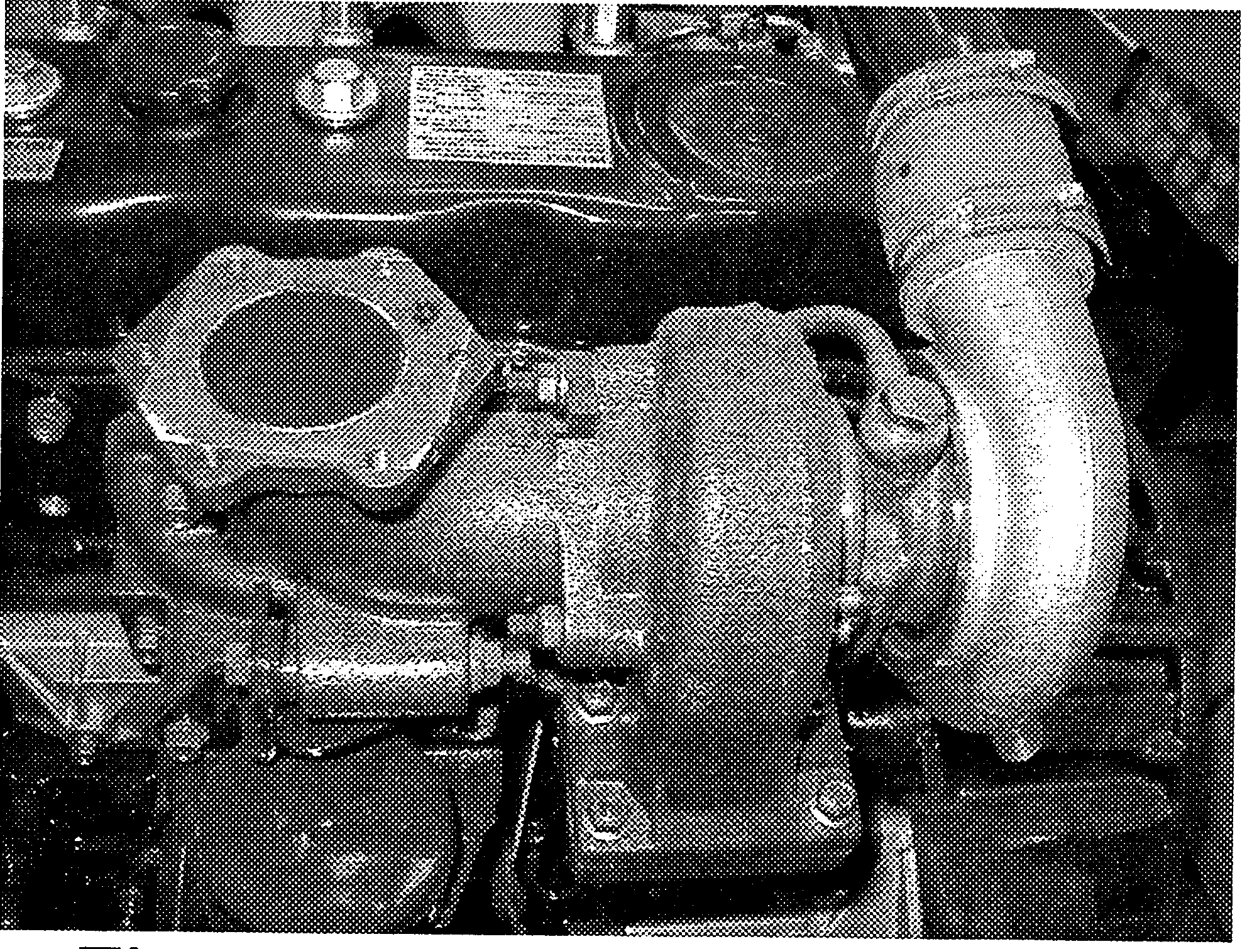
Figure 2-6: Turbocharger of 4BGlT

Valve Train
The B-series engines uses a pushrod / rocker arm system to actuate the valves. The

fulcrum-type rockers pivot on a single steel shaft. Valve lash adjustments are made at the push rod side with the adjuster at each rocker arm. (Figure 2-7 and 2-S)
Figure 2-7
Figure 2-8
NOTE: When the paint color code is centered on the coils 01 t/ze valve sprtng, the valve

springs can be assembled in any direction (Figure 2-B). Directional springs are available on some engines, and they are installed with the painted-end facing down.
Shaft Lubrication
The rocker shaft is pressure fed oil through

a gallery machined in the cylinder head. This gallery intersects with the main oil gallery in the block to provide full pressure oiling. The fed oil to the cylinder head reaches the rocker shaft and finally the rocker arms through number one rocker shaft bracket.
Figure 2-9: Undercut bolt at #I bracket
IMPORTANT: When replacing the head gasket, be sure that the oil hole in the gasket is

aligned correctly with the oil gallery in the block. In addition, the under cut bolt must be installed in the number one rocker shaft bracket for proper oil fi!ow, or oil will be prevented from reaching the rocker shafts. (Figure 2-9)

Cylinder Head
The B-series engine uses a one-piece cast iron cylinder head. (Figure 2-10)
Figure 2-10
The following features are common to all B-series engines.

q Removable seats
* Removable valve guides
a Direct injection combustion chambers
+ Cooling provisions in between the,i.ntake and exhaust seats
IMPORTANT:
 Before removing the cylinder

head from the block, always remove all fuel injectors as well as the glowplugs.

 Always cheek valve seat

depression before assembling the cylinder head (Figure 2-11).

NOTE: This is measuring valve

depth in head. Excessive measured valve seat depression may be the result of machining the valve seats too deep in the head or machining the valves too much, even when machining of seats are correct.
.,. .:..._..... . . . _._.._.... . .._..,.,.,.,.. .,.,.,.,.,.. . . . . . ...,.,.,.,. .,.,., ,.;,._., , ,.,.,.,,,,,.,,,.,.,,,,,., << . . . . . . <
Figure 2-11

