Cylinder Head Gasket
The head gasket used in the 4BG and 6BG engines requires no retorque after the engine

break-in period. Cylinder head sealing is ensured by a multi-layered metal head gasket. Cylinder pressure is kept in check by a built-in “fire ring” that is crimped around each cylinder bore location. All fluid passages have pre-applied elastomeric compound for enhanced sealing. Any additional application of sealers or gasket adhesives is unnecessary.
NOTE: NQ sealers or liquid gasket materials are required for this type of gasket.
IMPORTANT: The head gasket must be installed with the FRONT TOP mark facing

forward. (Figure 2-12)
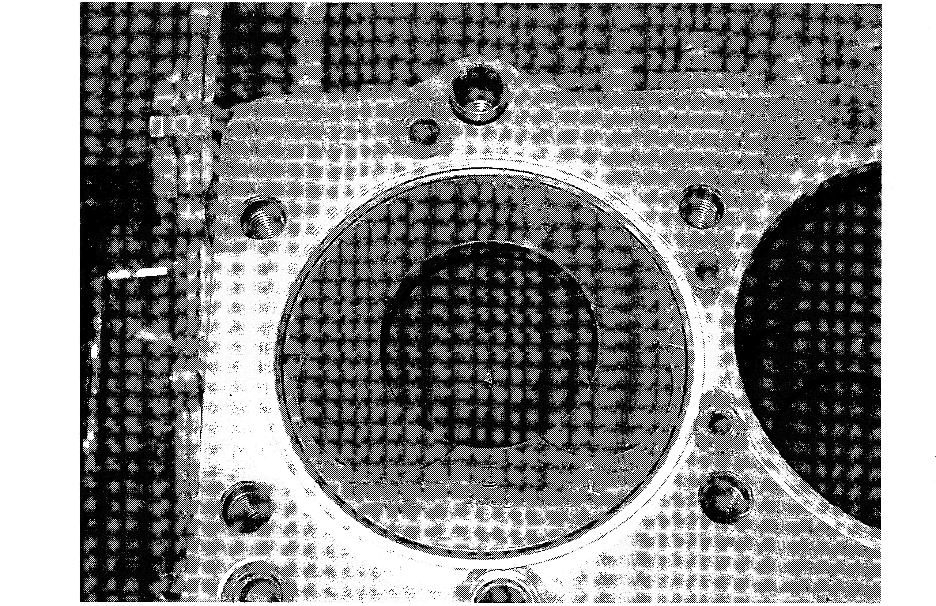
Figure 242: Install the gasket with “FRONT TOP” mark facing up and towards front.
10

Crankshaft Pulley
Timing marks at the front pulley area differ between 4BG-series and GBG-series engines.
4BG-series: (Figure 2-13 and 2-14)

0 Cover numbered stationary degree marks
 Pulley stamped pointer mark
Figure 2-13
Figure 2-14: Mark at TDC
GBG-series: (Figure 2-15 and 2-16)

 Cover stationary pointer
 Pulley - painted degree marks (TDC and 12’ to 20° marks in 2O increments)
Figure 2-15
Figure 2-16: Pointer at 12O

Crankshaft Pulley (continued)
The crankshaft pulley incorporates a mass damper. The.6BG-series incorporates a taper

bushing to assure a solid and centered mounting to the front nose of the crankshaft. It is
held in place by a large flat washer and a nut, which is also used as a wrenching point when turning the crank by hand. (Figure 2-17)
Figure 2-17
NOTE: For 6BG-series engine, a taper bushing remover (9-8521-0122-0) is used to remove the taper bushing. (Figure 2-18 and 2-19)
Figure 2-18: Install and turn bolt Figure 2-19: Remove the bushing
12

