Timing Gears
When the gears are timed correctly, the marks on the crankshaft gear, idler gear,

camshaft gear and injection pump gear should line up to position. (Figure 2-20)
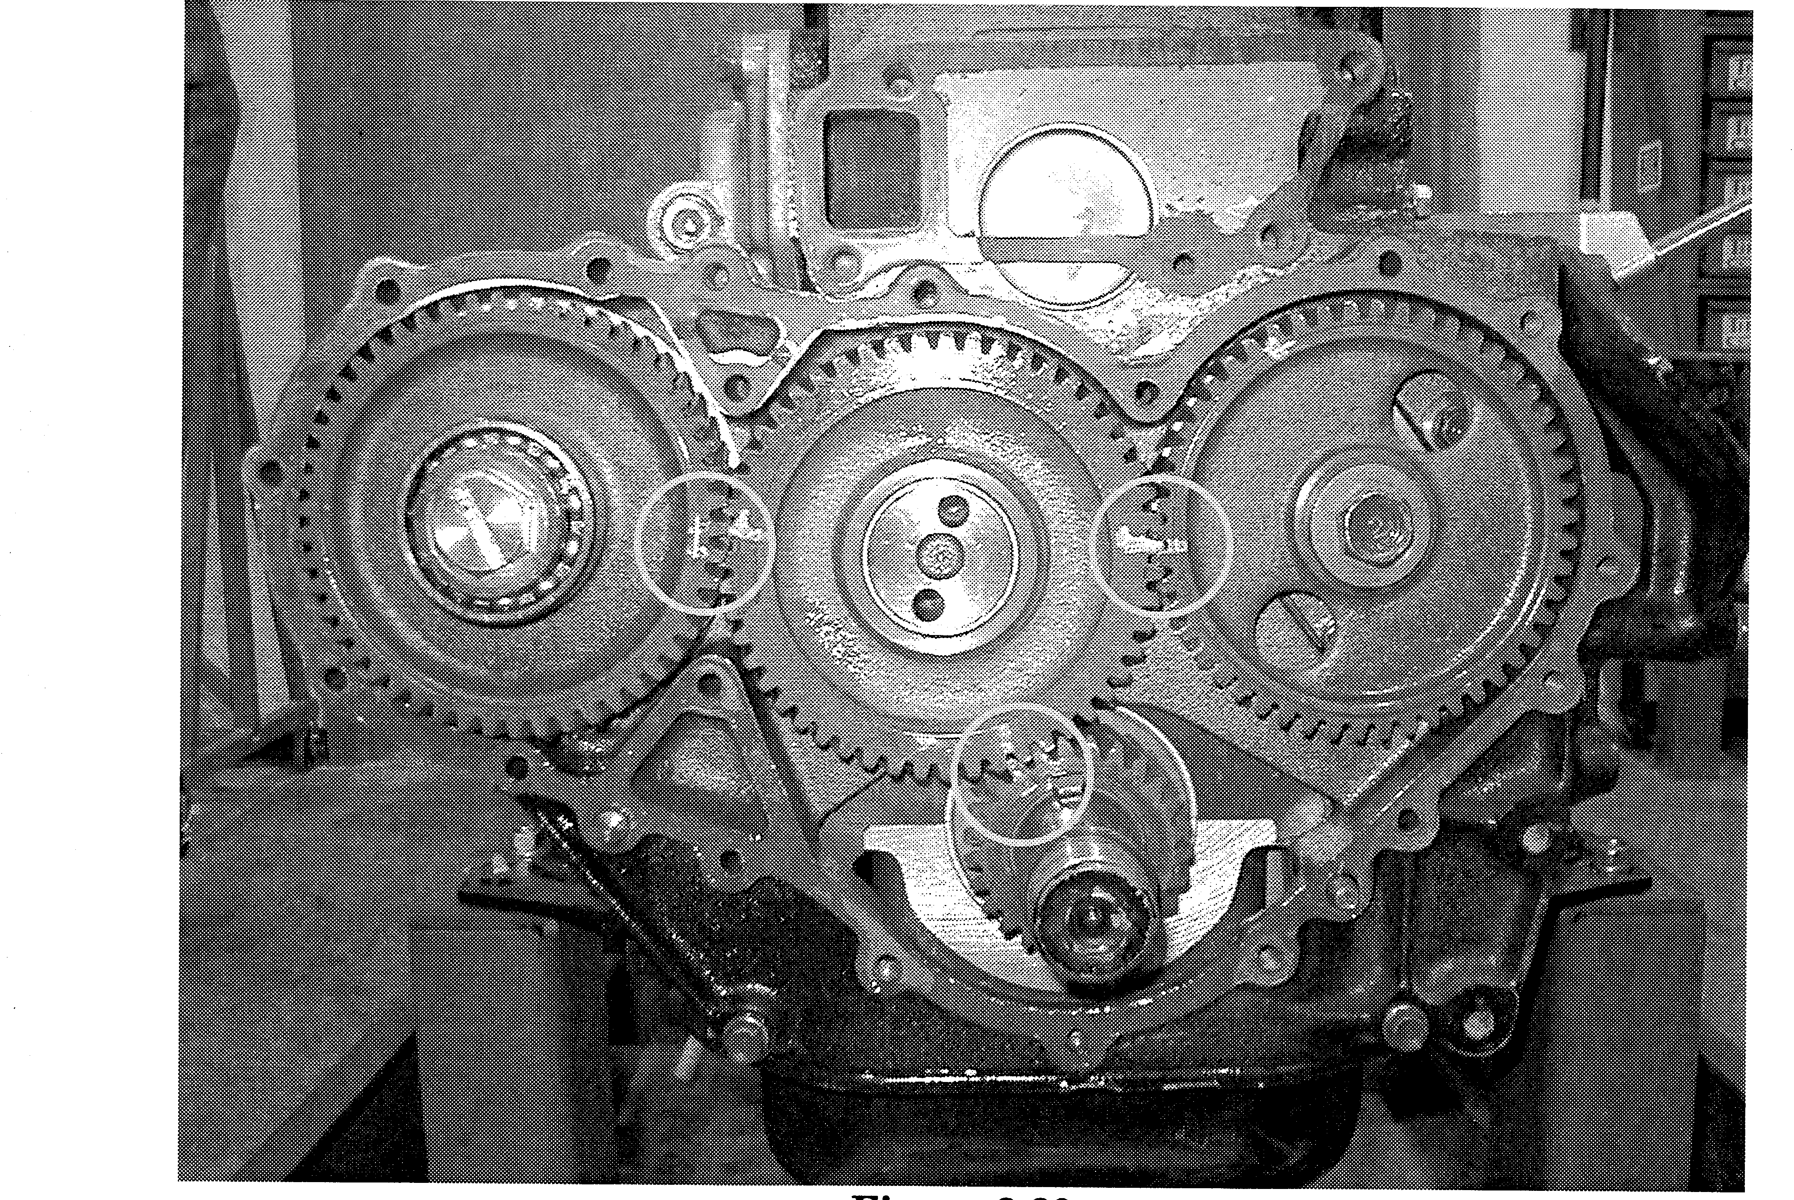
Figure 2-20
IMPORTANT:
Due to the combination of different gear

ratios, after the engine has been rotated a few times, the timing marks will not line-up with their respective gears. (Figure 2-21)
NOTE:
To verify TDC without removing the entire

timing gear case cover, remove the inspection plate from the gear case Cover and align the mark on the cam gear with the pointer on the case cover.
(Refer to Figure 3-7 in Section III.)
Figure 2-21
13

Camshaft
The B-series engines use a cast steel camshaft mounted in-block. The camshaft is a

standard flat tappet design (roller camshaft and lifters are used only for automotive specs) and periodic valve adjustment is required.
Camshaft Removal:
Rotate the engine until the 8mm camshaft thrust plate bolts are accessible through the

gear.
Remove the bolts from the thrust plate.
Remove the tappet chamber covers
Raise the tappets to clear the camshaft journal (Figure 2-22)
Due to clearance problems in the block, the tappets must be removed through the bottom of the block, if removal is necessary.
Remove the oil pump drive shaft
NOTE: The camshaft timing gear does not have to be disassembled to remove the camshaft

from the block.
Figure 2-22: Use a suitable tool to lift the lifters off the cam lobes and journals.
14

Crankshaft
The B-series crankshaft is forged steel with tufftrided journal surfaces. This type of

treatment is much harder than conventional induction hardening treatments to allow better wear characteristics. However, due to the shallow penetration of the tufftriding treatment, regrinding of the shaft should not be performed.

IMPORTANT: If the crankshaft journals are out of specification, it must be replaced. It
cannot be machined.
Cylinder Block
The cylinder block is composed of cast iron and features replaceable dry-type chromard

liners. (Figure 2-23) The cylinders and the deck surface are cast together giving the block extra support around the tops of the cylinders. (Figure 2-24) The cylinders are cast Siamese, but there are water circulation slots in between the cylinders to allow coolant to circulate around the periphery of the cylinder. Each main cap is numbered to its corresponding main saddle bore.
Figure 2-23
15
Figure 2-24

