Pistons and Connecting Rods
The B-series engines feature

aluminum pistons and steel connecting rods.

The pistons have two

compression rings and one oil control ring.

In addition, the piston pins

are retained by snap rings.
(Figure 2-25)
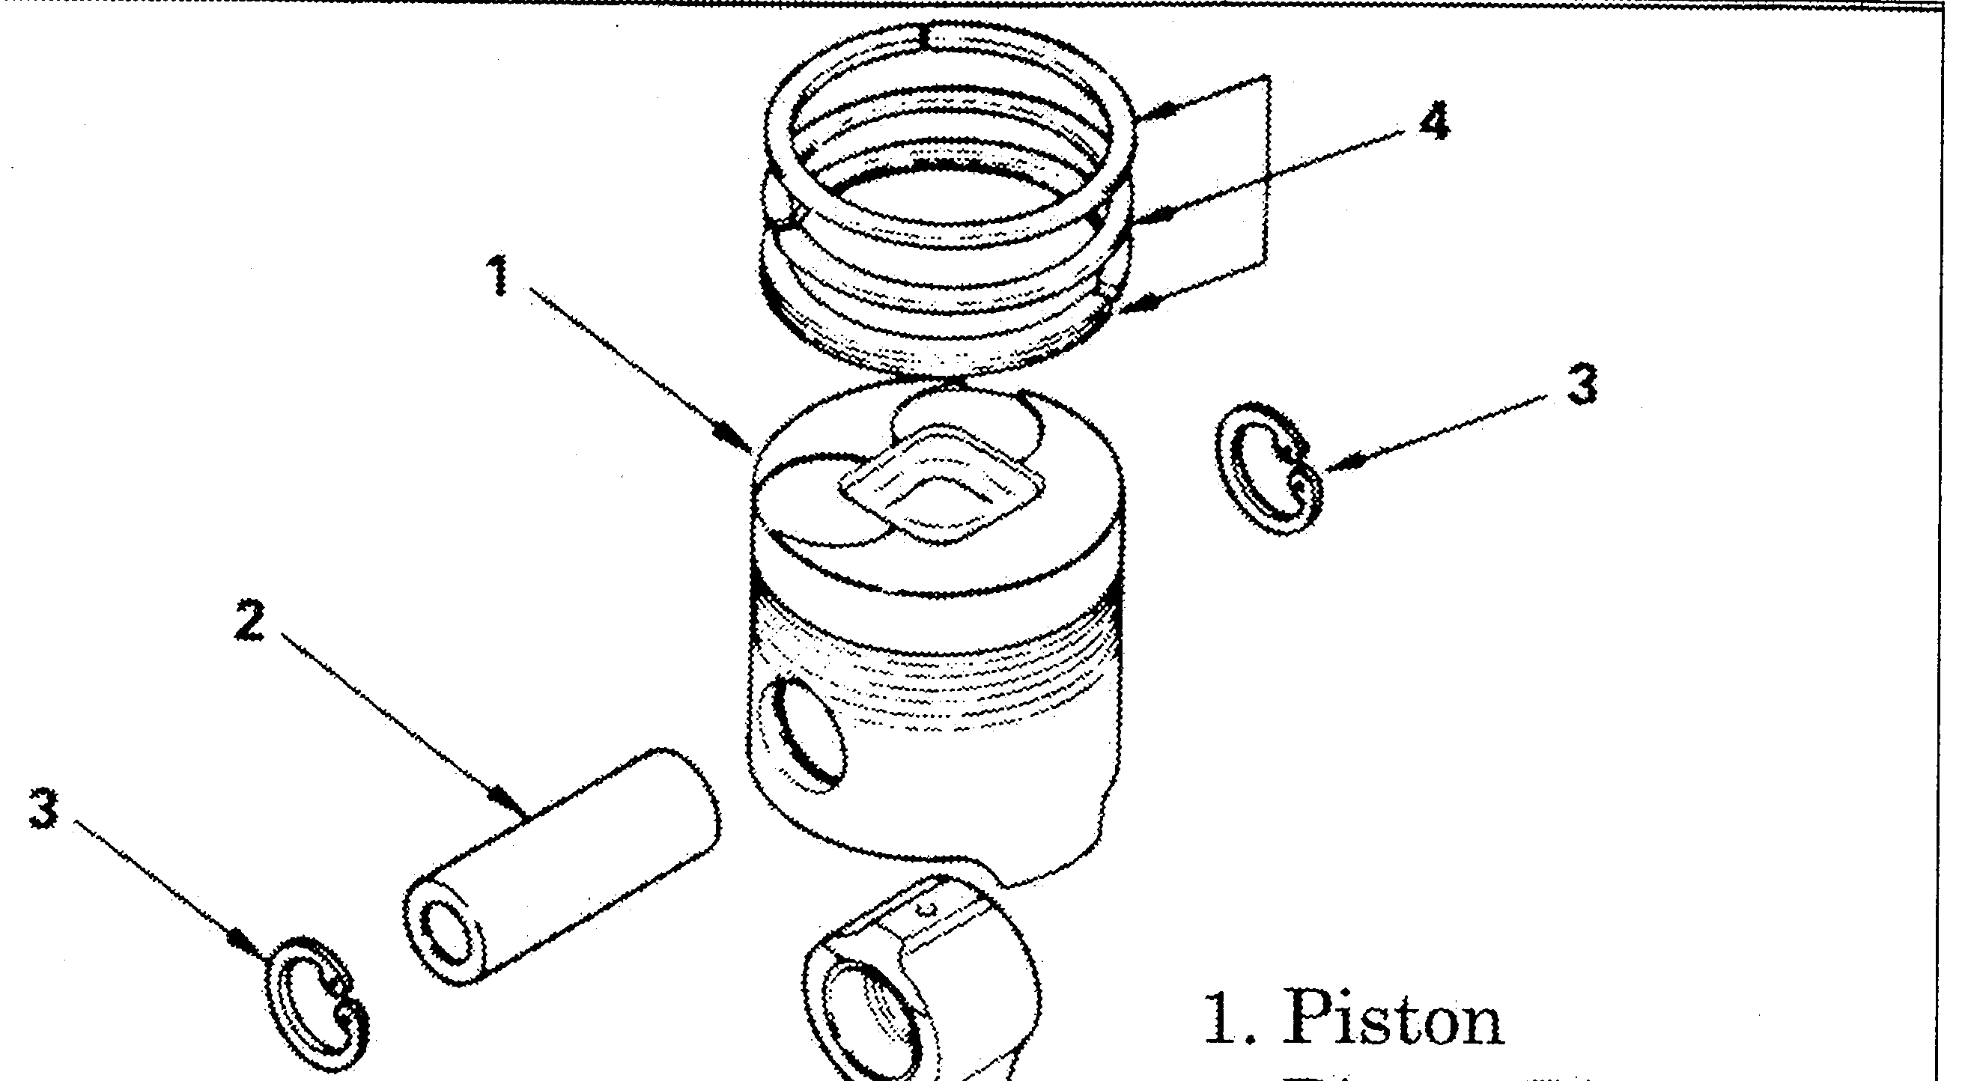
2. Piston Pin
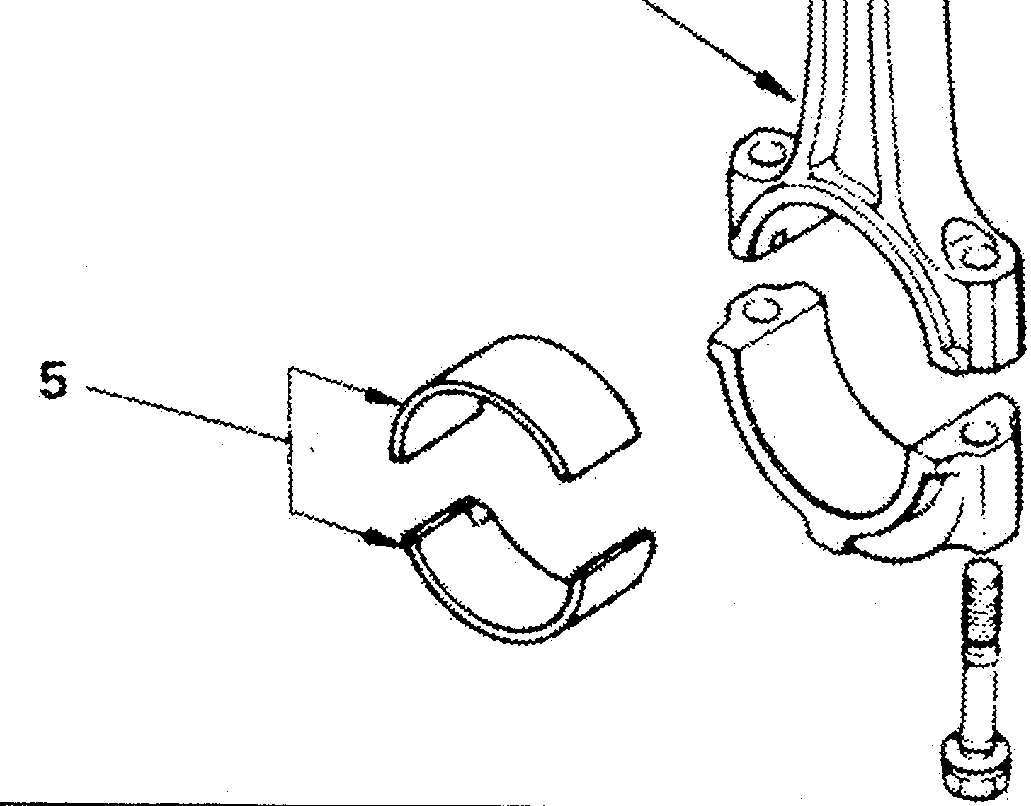
4. Piston Rings

5. Rod Bearings 6, Conraecting Rod
Figure 2-25
 Connecting rods are assembled to the piston with the cylinder number marked side of

the rod facing the exhaust side of engine. The notch on the piston head indicates forward
(Figure 2-26).

 The piston rings are installed to the piston with the marked side facing up (Figure 2-27).
16
Bdarked aide t,ip
Figure 2-26: Rod placement to piston.
Figure 2-27: Piston ring placement

Pi&tons
Figure 2-28
Pistons are matched during assembly to the liner sleeve bore internal diameter dimensions. The number

stamped on top of the piston represents the last four digits of that piston’s part number.

The letter stamped on top of the pistons denotes the piston grade (for outside diameter). At the time of

production, matching piston grade letters have also been stamped on the block deck surface adjacent to the appropriate piston. (If it doesn’t, the piston and liner has been replaced.)

Replacement pistons are only available in kit form with matching liners. When piston replacement is

required, the liner of that cylinder must be replaced as well. A replacement liner which fit into that cylinder body inside diameter, may not necessarily use the same piston grade which is stamped on the block deck surface.

IMPORTANT: It is important that all liner and piston overhauls be done using matching new parts

supplied in the kit. Prior to ordering the piston and liner kit, liner grade selection must be properly
made by taking measurements of the cylinder body inside diameter for the afleeted cylinder.
17

Cylinder Liners
B-Series engines use replaceable cylinder liners. A kit containing a new piston and liner

is used when servicing engines. The liners for these engines are made from high carbon steel material. It features chromard wear surfaces to reduce cylinder wear.

IMPORTANT: The triers feature chromard wear sufaces. Any machining process that1’
removes material will damage the surface and is not recommended by Isuzu. Also, once the liner is removed from the block, it must never be reused.

Liner Replacement:

The replacement liners are pressed into the block with a slight interference fit. The replaceable liners are dry-sleeve type, so seals or gaskets are not required during liner overhaul. Special tools are required for liner overhaul (Figure 2-29 and 2-30).
Figure 2-29: Liner Removal Tools Figure 2-30: Liner Installation Tool

 Cylinder Liner Remover 9-8523-1169-O 0 5-8522-1018-O (BG-series only)
 Liner Remover Ankle: 5-8523-1004-O  9-8523-2554-O (BD-series only)

NOTE: The liner and piston kit needs to be sized according to the number stamped on the

block, or as determined by the ‘Cylinder Body Inside Diameter MeasuremenYprocedure outlined in the appropriate workshop manual.
IMPORTANT: After installing the

cylinder liner, the cylinder liner projection must be measured. Total protrusion is the amount of liner flange thickness minus the block flange depth. (Figure 2-31)
Figure 2-31

