PRODUCT SERVICE INFORMATION
PSI # :
Date : | 27 May 2005
Product : | Wedge controlled compressors
Subject : | Code RD4

 DID YOU KNOW …

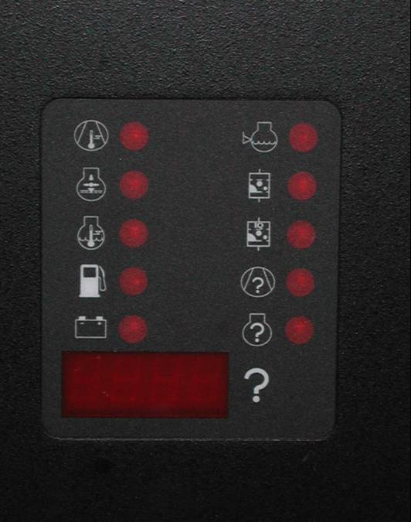
When code RD4 appears on the wedge controller, you lost the program in the wedge.

Using the PDA tool (virtual technician), you can easily program the latest version software into the controller.

More information about the program and machine ID programming can be found in the Electric/Electronic service manuals specific for your compressor, now available on your IRNET-ESA

RD4

