MODELS | SERIAL NUMBER
All models with EDF earthing possibilies

General info:
RCDs are designed to prevent electrocution or fire protection by detecting the leakage current. These adjustable units can be set for 30milliamperes or more and incase of leakage the device will trigger the circuit breaker.
The British standard and the European norm (IEC 60947-2 ) are giving the maximum braking times of the RCDs.

Findings: By miss using / incorrect earthing the generator the RCDs are tripping on incorrect values or in worst case not tripping at all.
RCDs are intended to operate within 100 milliseconds at 30mA and around 40milliseconds at 300mA.
According the legislation this is far below the allowable maximum trip times of 300msec at 30mA.

It could be that the generators will come without the Neutral to Earth connected in the main terminal box. To create a safe working environment we have to make sure we create a TN or TT earthing system on the generator for the correct way of working of the RCD. See fig 1
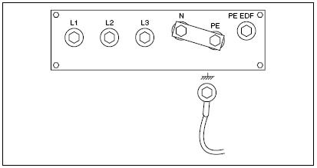
Pict 1: Starpoint of generator connected with Neutral and Earth.

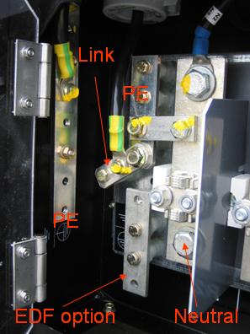
Pict 2: Correclty connected Starpoint from generator with neutral and PE.

Changing this earthing system from a TN or TT to an EDF-unit has to be carried out by a qualified person from “Electricité du France EDF”
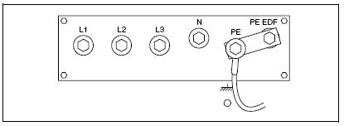
Pict 3: Starpoint of generator disconnected with Neutral and Earth EDF mode.

Incase of any question please don’t hesitate to contact me on: Peter_Schakel@eu.irco.com

