GENSETS

PC-12-011

SUBJECT: Incorrect parts listings on Mitsubishi Engines

MODELS AFFECTED: G8 through G40

Parts listed in manual may not be correct for all engines, Incorrect parts ordered

Production changes

Identify the proper engine model by looking for model number
on top of valve cover.

Please use the Mitsubishi parts listings at the rear of the
Manual, Using the corresponding line in the manual find the
Correct Mitsubishi part number and order the needed parts.

SYMPTOMS:

CAUSE:

REMEDY:

ACTION: .

The 1 represents the correct part number for this engine model

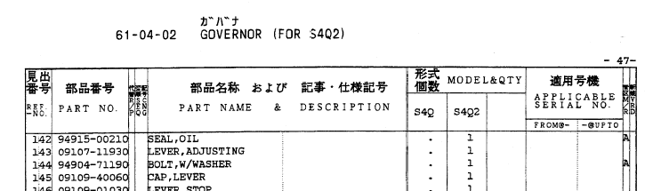
Note the * is showing this part number is not compatible to this engine model number

